Michaels Stores, Inc.
Carrier Education:
Ship2Michaels
Load Management
(Version 3.0/September 06, 2007)

Document Information
Business Process: | Carrier Education
TM Version: | 6.2.2
Document Title: | Ship2Michaels Load Management
Document Revision: | Draft 1
Revision Date: | September 06,2007
Document Reference: | Contact author for location of latest file.
Primary Author(s): | Joy Birdsong
Comments:

Overview 3
WEB Access 3
User Login 3
Search Function 4
To search: 4
Manual Acceptance of a Tender 5
Find a Tender: 5
Accept a Tender 5
Manually Reject a Tender 7
Manual Load Confirmation 8
Find a Load to confirm: 8
Confirm P/U on Load 9
Manual Delivery Confirmation 10
Find a Load to confirm Delivery on 10
Confirm Delivery on Loads with Multiple Drop Stops 11
Confirm Delivery on Loads with One Drop Stop 13

Overview
Carriers are responsible for updating each of their assigned loads to show the proper pick up and delivery dates and times. If a pick up is not processed against a load, the load will appear on the “Missed Pick Up Report”. If the pick up and delivery statuses are not properly processed, the load will also appear on the “Incomplete Load List Report”.

The following instructions will walk a carrier through the search functions of the Ship2Michaels WEB site, manually accepting or rejecting a tender, manually entering the proper information to show a load has been “Picked Up” which will remove it from the Missed Pick Up Report and completing delivery information so the load is removed from the Incomplete Load List.

WEB Access
All carriers will be given WEB access to www.Ship2Michaels.com. This will allow the Users to view and manage their Michael’s loads the “Tender Response Window”.

Each Carrier has been asked to determine representatives that should be set up with Logins. Each User should have an assigned User name and password. For security reasons, please do not share access information.
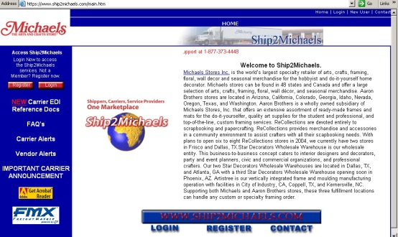

User Login
- User will go to www.ship2michaels.com and select the “Login” option on the left menu bar.
- A Login Window appears.

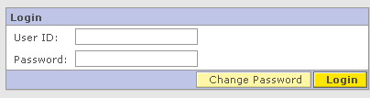
- User enters his “User ID” and “Password” and selects “Login”. ****Note**** User name and Password are case sensitive.
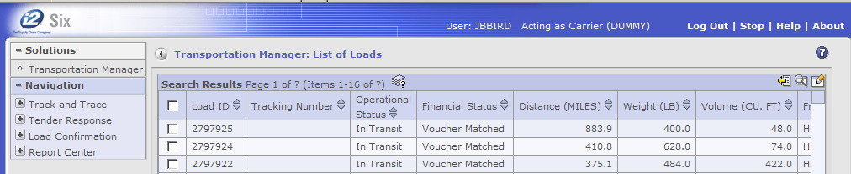
- User is brought to the “List of Loads” screen. This view, will default to a list of loads that meet the previously used search criteria.

Search Function
The search function for the site changed with the implementation of the newest software release that was effective in July, 2007. Previously there were separate buttons available under the various menu options to search for loads or tenders. These buttons were replaced by a “Search” icon () that is available on any list where a search feature is supported.

The search icon is located on the window title line to the right side.

To search:
- Click on the “Search” icon ()
- User is brought to the appropriate search screen for the list display.
- User enters search criteria and clicks on “Search” located in the bottom right side of the displayed window.
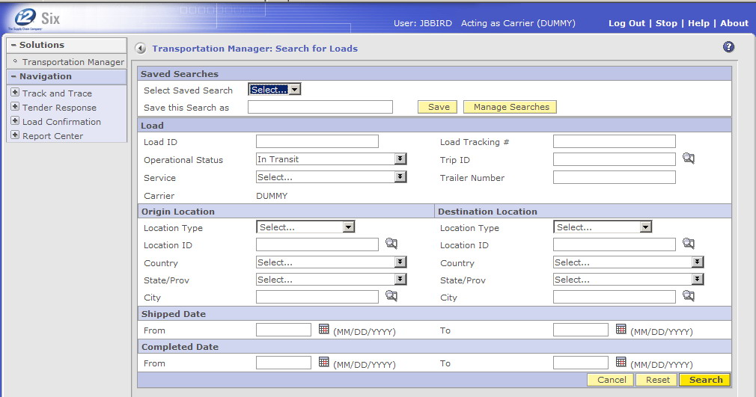
- User is brought back to the List, grid view showing records that match the search criteria that was entered. Please note that the records displayed in the list view are controlled by the last search criteria entered even if the User logs out and then re-enters the system at a later time.

Manual Acceptance of a Tender

Find a Tender:
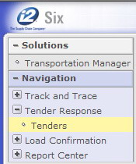
- User expands the menu options under the header “Tender Response” located on the left menu bar by selecting the “plus sign” next to it. The menu expands. User selects “Tenders”.
- User is brought to the “Load Tender List”. The view will usually default to any tender that is currently in “Tendered” status.
- The User can view details of the tender by selecting the radio button next to the Load ID field and selecting any of the yellow highlighted options located at the bottom of the window. These options include:
  - Memo
  - Contacts
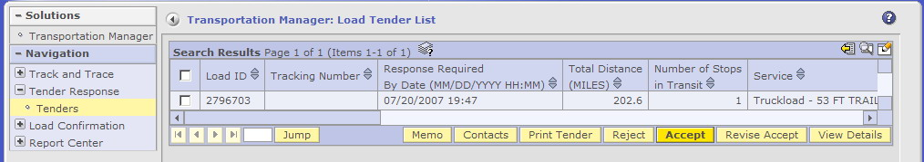
  - Print Tender (Pop ups must be enabled in your WEB browser and Adobe Acrobat is required)
  - Reject
  - Accept
  - Revise Accept
  - View Details

Accept a Tender
- To “Accept” the load, the User selects the radio button located next to the Load ID field and selects the “Accept” button located at the bottom of the window.
- The User is brought to the “Load Tender Accept” screen.
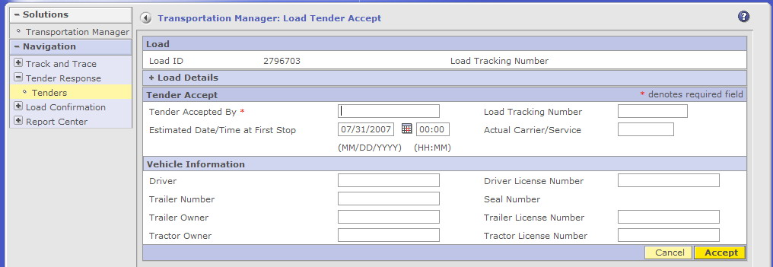
- The only field that the carrier should complete is the “Tender Accepted By:” field. Enter the User’s name and select the “Accept” button located at the bottom of the window. Do not change the value in the “Estimated Date/Time at First Stop” field.
- The User is brought to the “Load Tender List” screen. A message is displayed: Tender for (Load ID) is accepted. Please notice that the “Tender” you just accepted is no longer visible.
- To view the tender, select the search icon () located on the window title bar. (Please Note***Once a Load has been reported as “picked” up and is in “In Transit” status it can no longer be “seen” under the Tender Response header option. You will have to search for the load using the search icon on the List of Loads view under the Track and Trace menu option, Loads.)
- The User is taken to the Load Search Screen.
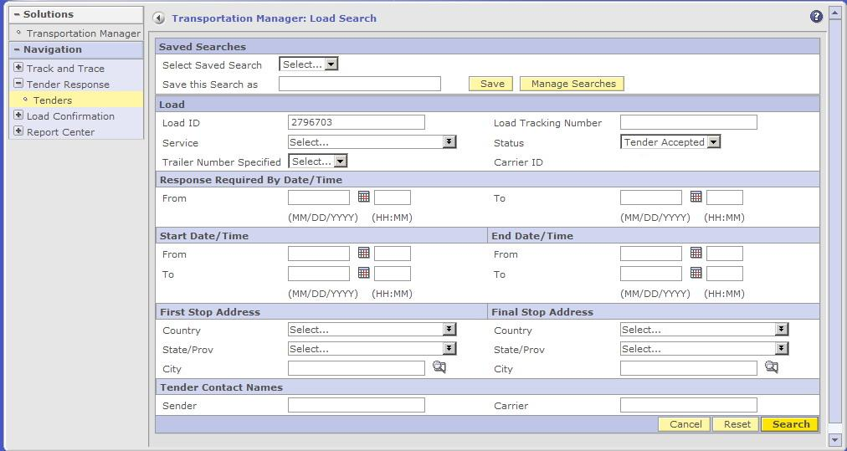
- User puts in the Load ID # and changes the “Status” option to “Tender Accepted” and selects “Search”. Remember that the Tender List display will show records that adhere to the last search criteria used by the User even if the User logs out and back into the system.
- The User is taken to the “Load Tender List”.

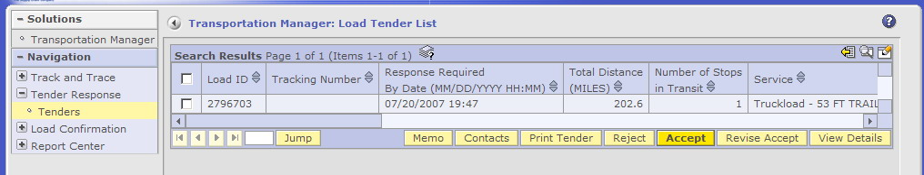
Manually Reject a Tender
- User finds the tender they want to reject by following steps # 8 through 11 above.
- User is brought to the “Load Tender List”. The view will default to records that adhere to the last search criteria used by the User.
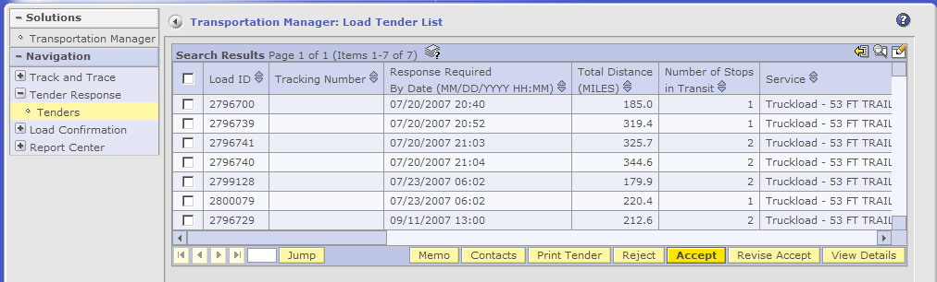
- The User can view details of the tender by selecting the radio button next to the Load ID field and selecting any of the yellow highlighted options located at the bottom of the window. These options include:
  - Memo
  - Contacts
  - Print Tender (Pop ups must be enabled in your WEB browser and Adobe Acrobat is required)
  - Reject
  - Accept
  - Revise Accept
  - View Details
- To “Reject” the load, the User selects the radio button located next to the Load ID field and selects the “Reject” button located at the bottom of the window.
- The User is brought to the “Load Tender Reject” screen.
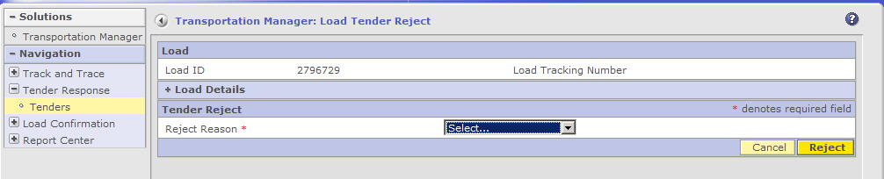
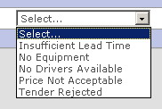
- The User selects a “Reject Reason” code from the drop down box, and selects “Reject”.
- The User is brought to the “Load Tender List” that displays a message: Tender for (Load ID) rejected.
- The “Tender” is no longer visible in any of the carrier’s views.

Manual Load Confirmation
The following instructions will walk a carrier through manually entering the proper information to show a load has been “Picked Up” which will remove it from the Missed Pick Up Report.

Find a Load to confirm:
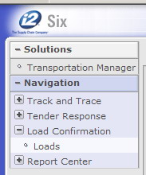
- User expands the menu options under the header “Load Confirmation” located on the left menu bar by selecting the “plus sign” next to it. The menu expands to show “Loads”. User selects “Loads”.
- User selects the “Search” icon located on the window title bar. See above for instructions on searching.
- User is brought to the “Search for Loads” list.
- The User puts in the search criteria to find the load that they want to confirm the pick up on and selects “Search” located at the bottom of the window. Please note that only loads that are eligible for P/U Load Confirmation are available in this view. Once a Load is “confirmed”, it is no longer visible in this view and can only be viewed through the “Track and Trace” option.
- User is brought to the “List of Loads” screen.

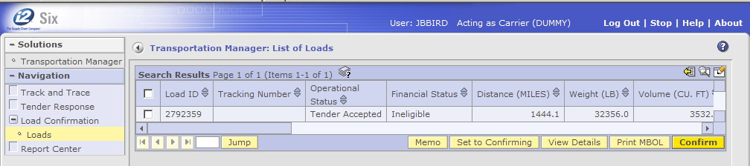
Confirm P/U on Load
- To “Confirm” the load, the User selects the radio button located next to the Load ID field and selects the “Confirm” button located at the bottom of the window.
- The User is brought to the “Load Confirmation” screen.
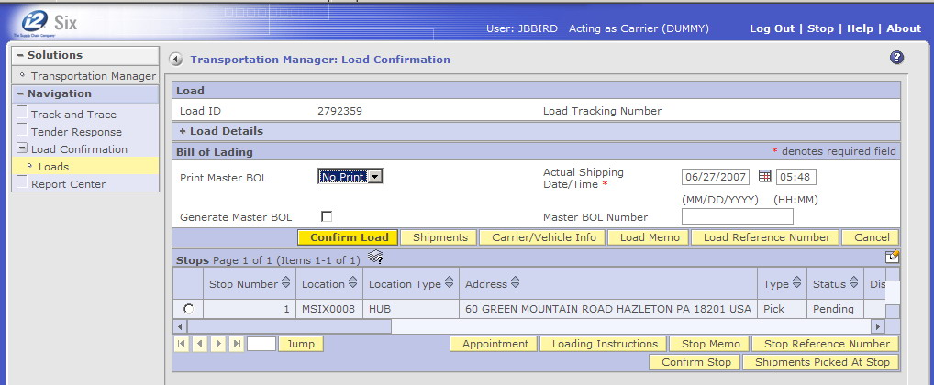
- The User edits the “Actual Shipping Date/Time” if needed (this date and time will default to the system “scheduled” date and time) and enters the Load ID number as the “Master BOL Number”. The User selects the “Confirm Load” button located on the middle menu bar.
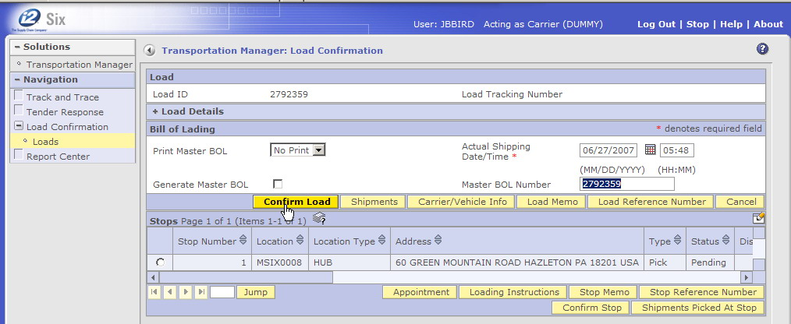
- If the confirmation was successful, a message will appear at the top of the window “Load (XXXXXXX) confirmed, Tracking Number: Master BOL # (XXXXXXX)”.
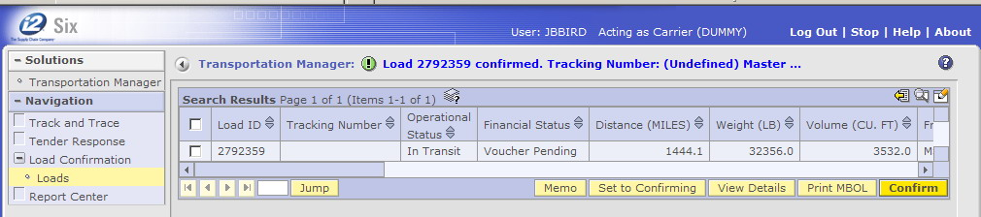
- All “Pick” stops on the load must be “Confirmed” to change to a stop status of “Picked Up” before any delivery at the final “Drop” stop can be updated.

Manual Delivery Confirmation
The following instructions will walk a carrier through manually entering the proper information to show a load has been “Delivered” which will remove it from the Missed Delivery Report.

Find a Load to confirm Delivery on
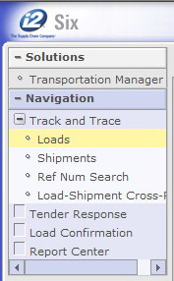
- User expands the menu options under the header “Track and Trace” located on the left menu bar by selecting the “plus sign” next to it. The menu expands to include:
- Loads
- Shipments
- Ref Num Search
- Load Shipment Cross-Ref
User selects “Loads”.
- User is brought to the “Loads” list.
- User selects the “Search” icon located on the window title bar. See above for instructions on searching.
- User is brought to the “Search for Loads” list.
- The User puts in the search criteria to find the load that they want to confirm the pick up on and selects “Search” located at the bottom of the window.
- User is brought to the “List of Loads” screen.

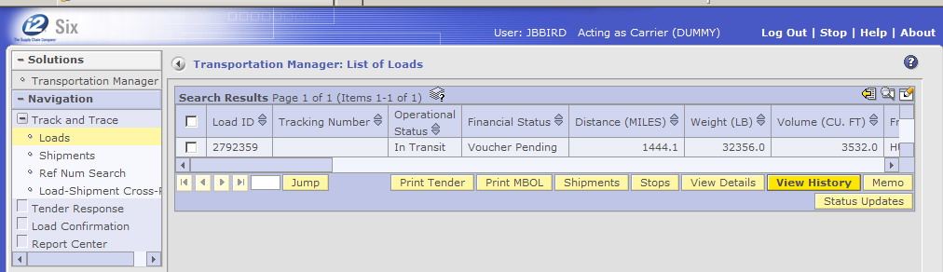
Confirm Delivery on Loads with Multiple Drop Stops
- To “Confirm the Delivery” on the loads with multiple stops, the User selects the radio button located next to the Load ID field and selects the “Stops” button located at the bottom of the window.
- The User is brought to the “List of Stops for a Load” screen.
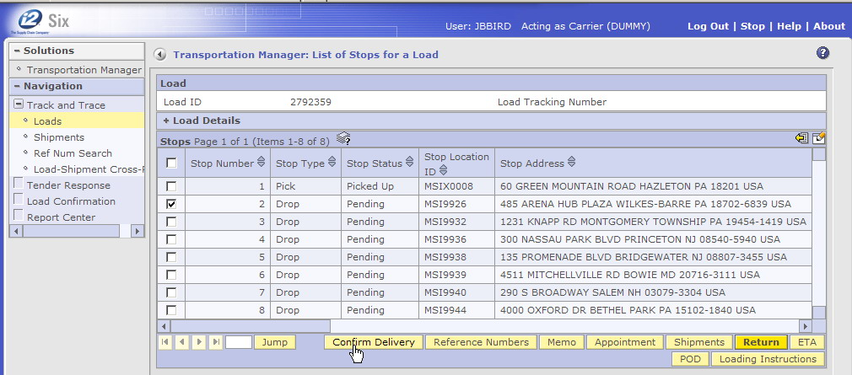
- All Pick stops need to be confirmed first. Please see above for instructions.
- The User selects the “Drop” stop they want to confirm by clicking the radio button located next to the stop number and clicks on the “Confirm Delivery” button located at the bottom of the screen.
- The User is brought to the “Confirm Delivery” screen.
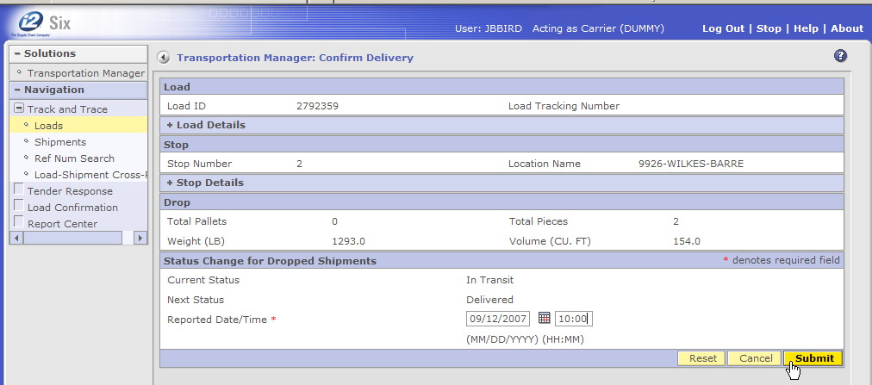
- The User fills in the “Reported Date/Time” which is the date/time that the delivery occurred and selects “Submit”.
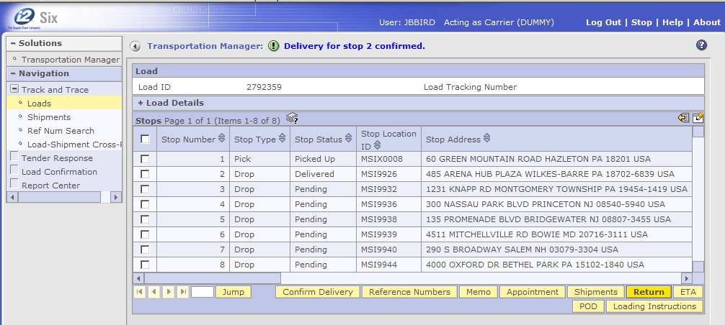
Upon successful update, a message is displayed
- Repeat until all “Drop” stops have been confirmed.
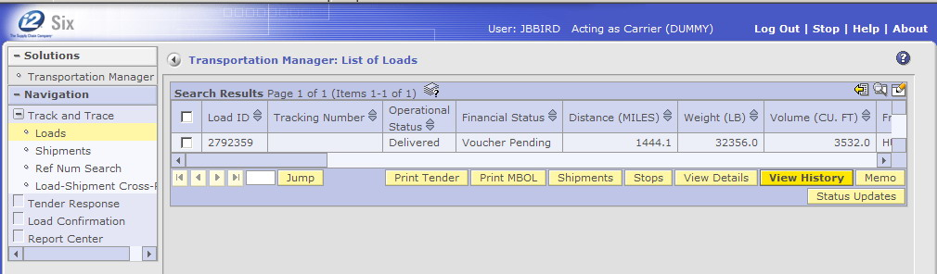
- Once all stops have been “Confirmed”, the status of the load moves to “Delivered”. No further updates are allowed once the load reaches this status.

Confirm Delivery on Loads with One Drop Stop

- To “Confirm the Delivery” on a load with a single drop stop, the User selects the radio button located next to the Load ID field and selects the “View History” button located at the bottom of the window.
- User is brought to the “Load History” screen. Click on the “Confirm Delivery” button located at the bottom of the window.
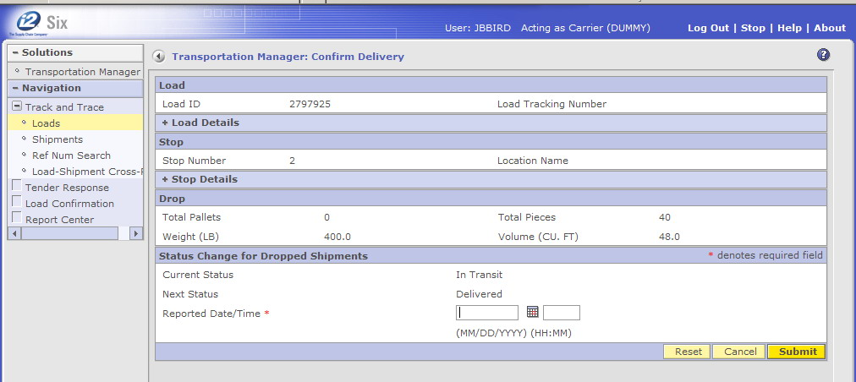
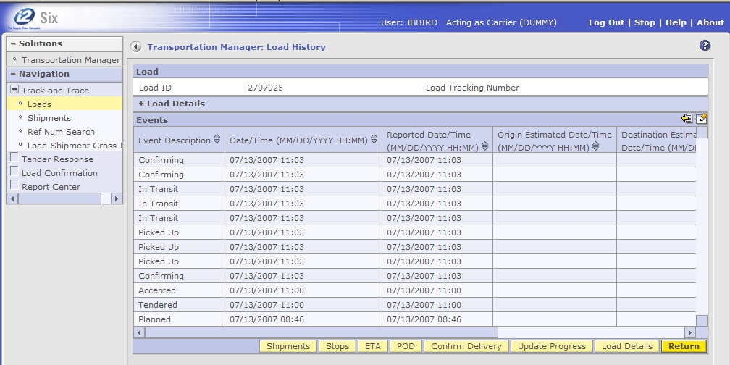
- User is brought to the “Confirm Delivery” screen. Fill in the “Reported Date/Time” which is the date/time that the delivery occurred and selects “Submit”.
- Upon successful completion, a message is displayed.
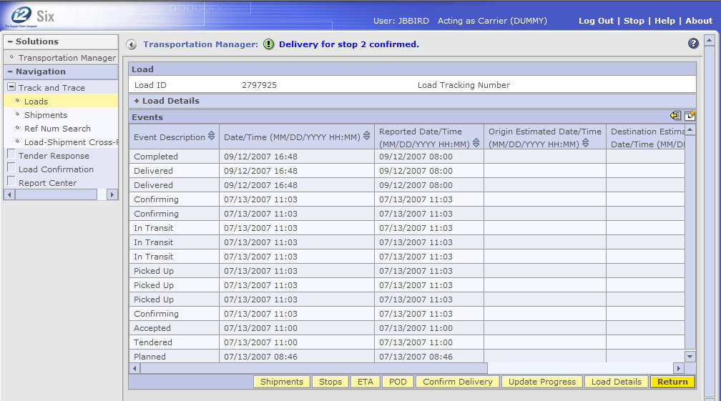
- The status of the load moves to “Delivered”. No further updates are allowed once the load reaches this status.

